**MICRO LAB QUESTIONS**

LAB DA1

Programs involving Arithmetic and Data Transfer Operations

**A. Addition:**

1. Write a program to add two 8-bit numbers and store the results in AX.
2. Write a program to add two 16-bit numbers and store the results in BX.
3. Write a program to add two 16-bit numbers stored in the memory location [1000H], [1002H] and store its final results in the memory location [1004H] in BX.
4. Write a program to add a data byte located at offset 0500H in 2000H segment to another data byte available to 0600H in the same segment and store the result at 0700H in the same segment.

**B. Subtraction:**

1. Write a program to subtract two 8-bit numbers and store the results in AX.
2. Write a program to subtract two 16-bit numbers and store the results in BX.
3. Write a program to subtract two 16-bit numbers stored in the memory location [1000H], [1002H] and store its final results in the memory location [1004H] in BX.
4. Write a program to subtract a data byte located at offset 0500H in the 2000H segment to another data byte available at 0600H in the same segment and store the result at 0700H in the same segment.

**C. Data Transfer:**

1. Write a program code to write the first five even numbers 0,2,4,6,8 at locations shown in the memory diagram.

Programs involving Multiplication and Division Operations

**A. Multiplication:**

1. Write an Assembly Language Program (ALP) to multiple two numbers of 16-bit data. The input data must load to the location given below and the output product should be stored as per the memory location given below.

|  |  |
| --- | --- |
| Input | Output |
| |  |  | | --- | --- | | Memory Address | Content | | 1100 | 1A | | 1101 | EF | | 1102 | 50 | | 1103 | CD | | |  |  | | --- | --- | | Memory Address | Content | | 1104 |  | | 1105 |  | | 1106 |  | | 1107 |  | |

1. Write an Assembly Language Program (ALP) to multiple two numbers of 16-digit data based on your roll number.

|  |  |
| --- | --- |
| Input | Output |
| |  |  | | --- | --- | | Memory Address | Content | | 2100 | 1A | | 2101 | EF | | 2102 | 50 | | 2103 | CD | | |  |  | | --- | --- | | Memory Address | Content | | 2104 |  | | 2105 |  | | 2106 |  | | 2107 |  | |

**B. Division:**

1. Write an Assembly Level Program (ALP) to divide 32-bit data by 16-bit data. The input data must load to the location given below, the output quotient and remainder should be stored as per the memory location given below.

|  |  |
| --- | --- |
| Input | Output |
| |  |  | | --- | --- | | Memory Add | Content | | 3100 | 0A | | 3101 | 58 | | 3102 | C2 | | 3103 | 71 | | 3104 | F2 | | 3105 | F6 | | |  |  | | --- | --- | | Memory Add | Content | | 3106 |  | | 3107 |  | | 3108 |  | | 3109 |  | |

1. Write an Assembly Language Program (ALP) to divide 32-bit data by 16-bit data based on your roll number.

LAB DA2

**Programs involving Arithmetic Operation of Signed Numbers**

**A. 16 Bit multiplication for signed numbers:**

1. **Write an Assembly Language Programme (ALP) to multiply 8 bit signed numbers.**
2. **Write an Assembly Language Programme (ALP) to multiply 16 bit signed numbers.**

**B.16 Bit Division for signed numbers:**

1. **Write an Assembly Language Programme (ALP) to divide 16 bit by 8 bit signed numbers.**
2. **Write an Assembly Language Programme (ALP) to divide 32 bit by 16 bit signed numbers.**

**C.Sum of N numbers:**

1. **Write a program to find the sum of N numbers**

LAB DA3

**Programs to find Factorial of a number**

**1. Write an Assembly Language Programme (ALP) to find the factorial of a number 6.**

**2. Write an Assembly Language Programme (ALP) to find the factorial of a number 7.**

LAB DA4

**EXPERIMENT 5:**

**1. Write an ALP Program to find LCM of a given numbers**

**2. Write an ALP program to find the average of N numbers.**

**3. Write an ALP to find the greatest among two numbers.**

LAB DA5

**Experiment 6:**

1. **Write an ALP program to find square and cube of a given number**

**2)**

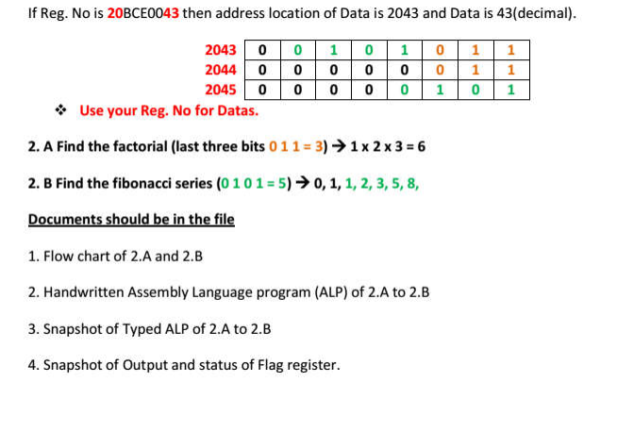

LAB DA6

**Experiment -7**

**1)Convert Binary number corresponding to 0109H to BCD number.**

**2) Convert BCD number corresponding to 27H to Binary number.**

**Experiment -8.1**

1. **Write an ALP program to sort the numbers in ascending / descending order**
2. **Write an ALP to find square and cube of an 8 bit number**
3. **Write an ALP to check if the given number is even or odd.**

**Experiment -9**

**Stepper motor**